# GaN Simulation Results

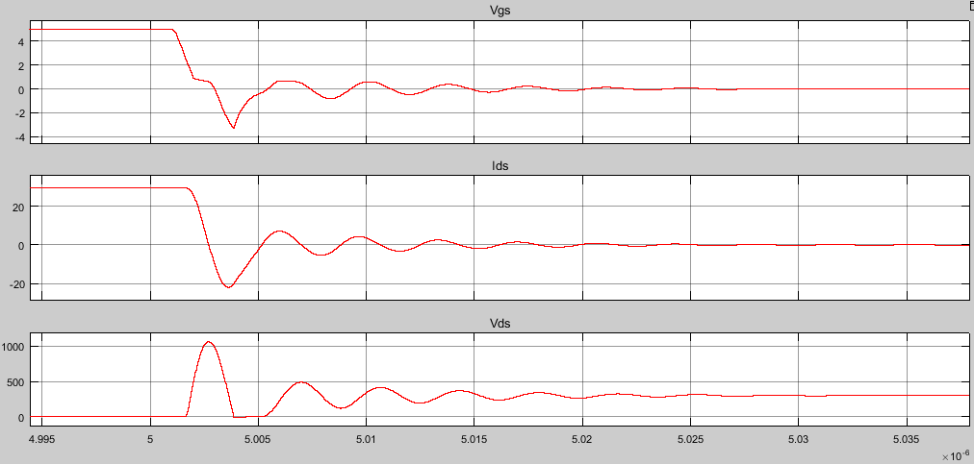

Figure 1: Turn OFF - From top to bottom: Vgs, Ids, Vds

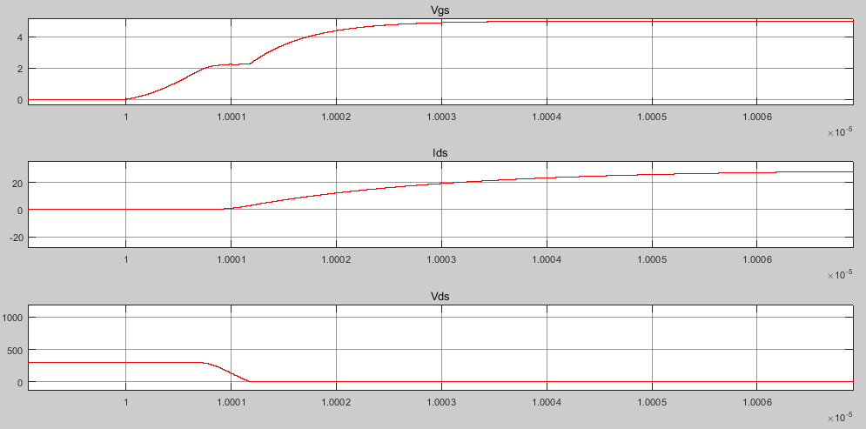

Figure 2: Turn ON - From Bottom to Top: Vgs, Ids, Vds